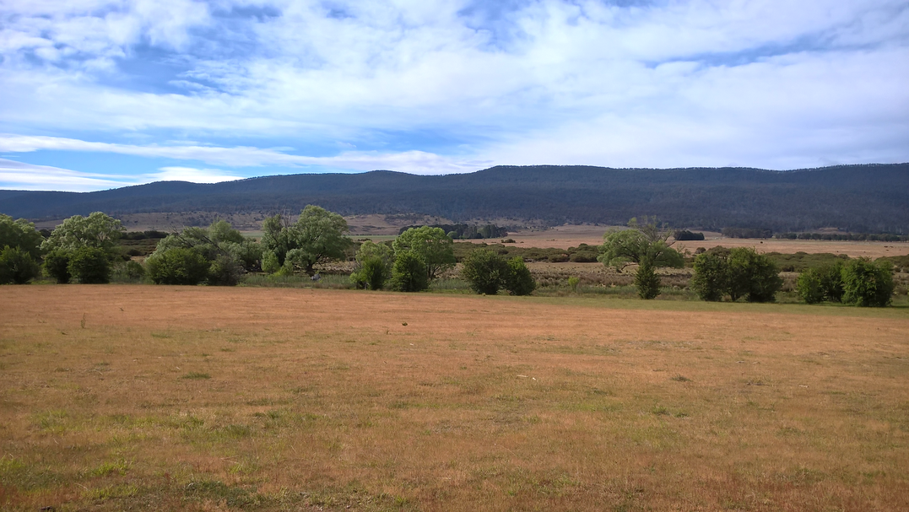

APPLICATION FORM
  - Break O’Day Council Drought Weeds Grant 2020
Date: 28 August 2020
Support for farmers to combat weeds during and after drought
Farmers in the Break O’Day have access to support to manage weed issues related to drought, as part of the Tasmanian Government’s Weed Action Fund Drought and Weed Management Program. The Break O’Day Drought Weeds Project will run over 2020-2021. It includes this offer of grants to farmers in Break O’Day impacted by drought to support targeted weed management of species that limit agricultural production.
Before filling out this form please be sure to
- read the Municipal Drought Weeds Grants 2020 - Guidelines and Eligibility
- contact the Drought Weeds Officer, Peter Heading (see below), to discuss your weed issues, solutions and the project you are seeking funding for.

Applications
Applications must be submitted by Sunday 27 September 2020 to admin@bodc.tas.gov.au, or to the Break O’Day Council office at 32-34 Georges Bay Esplanade St Helens. If Drought Weeds Grant funds remain unallocated a further round may be offered. Completed applications will be assessed and prioritised by a local assessment panel using the Guidelines and Eligibility document and grants determined by Break O’Day Council.

Activity location and weeds
Any recognised weed/s advantaged by drought threatening agricultural production in Break O’Day may be the subject of funding support. They could be on the applicant’s or another person’s land and pose a threat from farmland or non-farmland. Some weeds not currently known in Break O’Day are also a serious threat should they arrive here (requiring biosecurity and planning measures or awareness raising activities to reduce the risk). Applications from groups of landholders for cooperative activities and projects are encouraged.

Project size
The Break O’Day Drought Weeds Project has $30 000 available in total for grants. Projects needing any amount of funding support, large or small, are encouraged and will be considered on their merits. Projects using up to $3000 of funding support are desirable.

Urgent weed management
Early applications for funding support for urgent weed management may be considered where there is a very high priority, for example a serious new weed incursion related to drought that needs timely action. If you have such an urgent need contact the Drought Weeds Officer in the first instance.

Contacts
For questions or to discuss your application, please contact:
- Break O’Day Drought Weeds Officer, Peter Heading on pheading@nrmnorth.org.au, 0400 737 253 (Thursdays preferably).
- Or Break O’Day Council’s NRM Facilitator, Polly Buchhorn, polly.buchhorn@bodc.tas.gov.au, 0459 678 200.

Use the Drought Weeds Project as an opportunity
Even if you are unsure if your project will succeed in getting funded, you are encouraged to still use the Break O’Day Drought Weeds Project as an opportunity to investigate your weed issues and management and plan future weed projects. The Tasmanian Government’s Weed Action Fund will be offering its substantial 2nd round of Weed Action Fund Grants in 2020 with a wider scope of eligibility.

PART A: Applicant and Property Details
Applicant name:
Project Address:
Project Property ID (PID)
Applicant Postal
Address:
Contact person
Phone Number:
Email:
ABN
Registered for GST | Yes ☐ No ☐
* Insurance or  Incorporation | Copy of current Public Liability Insurance attached Yes ☐ No ☐ or,  Incorporated Public Association number:
Declaration | ☐ I have read and understand the Municipal Drought Weeds Grants 2020 - Guidelines and Eligibility and all the information I have provided in and with this application is true and complete.  ☐ More than 50% of my gross income is from primary production and have evidence of being a primary producer.  Name: Date  Signature:
*Copies/Details must be provided if application is successful.

PART B: Project Details

Title of the Project

Drought weed issues
What are the drought weed issues you intend to address? (weeds and impact/threats to agricultural productivity):

Drought and farm management
How has your ability to manage weeds and/or farm production been diminished by drought?

Project Description
Describe
- The on-ground control, biosecurity measures and/or education, training and awareness activities proposed
- How each will control, reduce the spread or prevent the emergence of drought-favoured weeds and their impact on agricultural productivity, including for awareness and education or planning activities the effective weed management outcomes they will deliver
- Method(s) to be used for each activity and site and the planned follow-up weed management.
Include individual activities and sites on the Project Map and Budget (PART C below). Photographs may be attached, activity/sites with a brief annotations identifying location, direction, features and reference on the Project Map.

Project Map
Attach or insert a map/s with annotations showing project area and other relevant details: weed infestation and activity/treatment areas and timing (if staged), assets such as fencing, access and crops (existing or planned), and nearby bush and aquatic habitat, production areas and other landowners. This bookmarked LISTmap may useful for a base map.

PART C: Project Budget
Detail for each project activity and site the timing, activities and tasks and items involved (e.g. works, equipment, materials etc.), who undertakes the work and costs and contributions. Funding sought must not exceed 66% of total project costs. Applicant contributions can include cash and in-kind (materials, machine time, labour etc.) valued at reasonable rates and at the discretion of the assessment panel.
Some drought weed management works by the applicant or project partner may included in ‘Funding sought’ and reimbursement, provided they are not day-to-day or required operational costs of a business. To be considered they must be itemised below and not exceed 50% of funding sought. Evidence, such as copies of machinery or labour time logs, must be collected and provided to substantiate such expenditure before it will be reimbursed. A Tax Invoice is required if gst is applicable.
Activities and Works |  |  |  | Funding sought (gst excl.) | Applicant contribution
Activity and location | Timing | Tasks, expenditure items and supplier/source
 |  |  | Subtotal applicant work claimed (gst,excl. - N/A)
 |  |  | Total (gst exclusive)
 |  |  | Total GST applicable
 |  |  | Total Project Values (gst inclusive)

PART D: Best Practice

Contractors
Are you using a contractor? Yes ☐ No ☐
If yes please attach a quote for the activities that they are undertaking and ensure this is included in your Project Plan and Budget. Contractors undertaking spraying should hold a Commercial Operator’s License for spraying. If using chemicals, the applicant agrees to read the label instructions and use only as directed. It is the user's responsibility to check that the registered label or an off-label permit covers the proposed use for the chemical.

Technical Advice
What technical information, knowledge, advice and guidance from others have you used to develop and plan your project? (EG. Drought Weeds officer, a licensed weed control contractor, agronomist, Weed Inspector, Biosecurity Tas., etc.)
Project activity | Technical support provided | Name/org. & contact number

Ongoing weed management
How will the proposed works be maintained into the future?

Existing Management Plans
Does the property have a weed management plan, farm biosecurity plan, property management plan, etc. to guide the proposed activities? Yes ☐ No ☐
If yes, please provide name of plan (s) and date (s).

PART E: Other Important Information

Property Ownership
Do you own the property where the proposed activities will occur?
Yes ☐ No ☐
If no, please provide a letter of consent from all the relevant landowners or land managers approving the proposed activities on their land. (Signed note or email from landholder. )

Public Assets, Values and Approvals
Show on your Project map public infrastructure, social, natural or cultural heritage values that are nearby. Will your project affect any of them?
Yes ☐ No ☐ If Yes please provide details of what they are and how you plan to manage the risk of any negative impacts on them?

It is the landowner’s responsibility to meet any legislative responsibilities for works on the property. Are there any works or planning approvals or permits needed for the activities?
Yes ☐ No ☐ If Yes please provide details.

Future Weed Projects and Priorities
Beyond this project, have you identified a need or have plans for further weed management projects that may benefit from funding support in future? Please provide some details of possible future projects you may like assistance with.

Past Funding Projects
Have you received any NRM, Landcare, Weed Action Fund or similar grants in the past 5 years?
Yes ☐ No ☐ If yes, please provide a brief explanation, funding source and amount, completion status.

